**Game analytics report – 6th of January**

**Group 5 – REAKTOR:**

Lou Bakker – game designer loujbakker@gmail.com

Dixie de Klerk – producer dixiedeklerk@me.com

Pim Klaassen – lead artist pim.o.klaassen@gmail.com

Joost Zwart – world builder joost.zwart@hotmail.com

Tim Hosman – lead programmer timhosman@hotmail.com

*“Did players reach their goal? Why?”*

Most of the goals throughout the game could be reached by the player, e.g. finding the first two key objects and outrunning Antag. However the final goal of Reaktor – reaching the reactor – was only achieved once. This is assumingly because of the very dense and small rooms of the archives; one of the last scenes to be accessed before the player can reach the reactor. Also, the dead ends caused by the archive closets contribute to this problem. It also turned out to be very hard to find the third key object in the archives (security note).

A possible solution for the first problem is to furnish these rooms with less closets. Alternatives are cutting out dead ends or even limit Antag to only access the hallways. A solution for finding the third key object could be enlighthening the object, so it will be easier to find.

Some statistics:

* 40% of the players died/quit before they found the key.
* 60% of the players died/quit before they found the crowbar.
* 93% of the players died/quit before they found the security note.

Game over locations on Reaktor map:

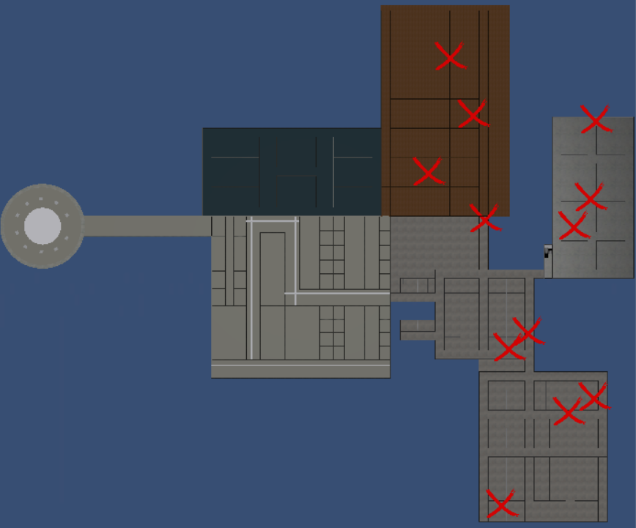

*“What are the players’ motivations for playing? Why? Is it what we expected?”*

The motivation for playing Reaktor is because it is a challenge. It can give players a good adreline rush as well. This is because of the constant fear of getting caught by Antag. The jumpscares strentghen this atmosphere. This is exactely what Reaktor aimes at. Not a lot of people dare to even play it, just like games as Slenderman or Amnesia. This is what makes horrorgames a lot of fun!

*“What bugs did occur? Why?”*

A couple of bugs occured throughout playing the game, summed up beneath:

* *Antag jams:* Sometimes during gameplay, Antag jams on corners of walls. Therefore he can’t catch you and besides that, he gets less scary. This problem is caused by Antag ‘making the wrong desicion’ walking to a certain waypoint. The consequence of this is Antags collider getting stuck in the wall.
* *Desks blocking doors:* In some places in the office, desks are blocking the doorways. This is because of scaling issues of furniture during procedural gerenation in small rooms. This sometimes causes the key to be unreachable.
* *Texture issues:* In a couple of places in the game, textures aren’t applied or rendered badly. This is probably because of wrongly scaled UV maps in Blender. This causes both unrealistic rendering of the game as strange reflections of light.
* *Game lag:* There is a lag on starting a new game and regularly during gameplay. This is caused because of an accumulation of different occasions. To start with, some models contain a lot of vertices and need decimation for smoother gameplay. In addition, the code and folders need to be cleaned up.
* *Key lag:* Sometimes when the game is started, the first key object is already placed in the inventory. In this case the player does not have to search for the key anymore. This problem is probably caused by not reseting the game correctly after the player died.